PERSONA 1 Core Memory Contributor
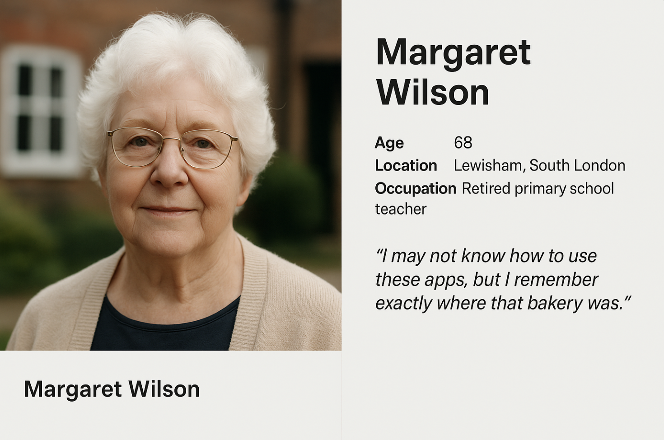

Name
Margaret Wilson

Age
68

Location
Lewisham, South London

Occupation
Retired primary school teacher

Background / Context
Margaret has lived in London all her life. She grew up around small, everyday local venues—bakeries, pubs, corner shops—that no longer exist. These places hold strong emotional significance for her, as they are tied to family routines and childhood memories.
She occasionally visits museums and values cultural heritage, but has never formally contributed to a digital archive. Her relationship with technology is cautious: she mainly uses a tablet for video calls, browsing the web, and emails.

Goals & Motivations
To preserve personal memories of disappearing neighbourhood spaces
To share lived experiences with younger generations
To ensure her memories are not lost when she is no longer able to tell them
To feel that her life experience has cultural value

Needs
A very low technical barrier to contribution
Voice-based input rather than text-heavy forms
Gentle prompts to help structure her storytelling
Clear reassurance about privacy and how her data is used

Pain Points
Finds typing slow and tiring
Feels intimidated by unfamiliar apps
Worries her stories are “not important enough”
Afraid of making mistakes or sharing something accidentally

Quote
“I may not know how to use these apps, but I remember exactly where that bakery was.”

PERSONA 2 Research User
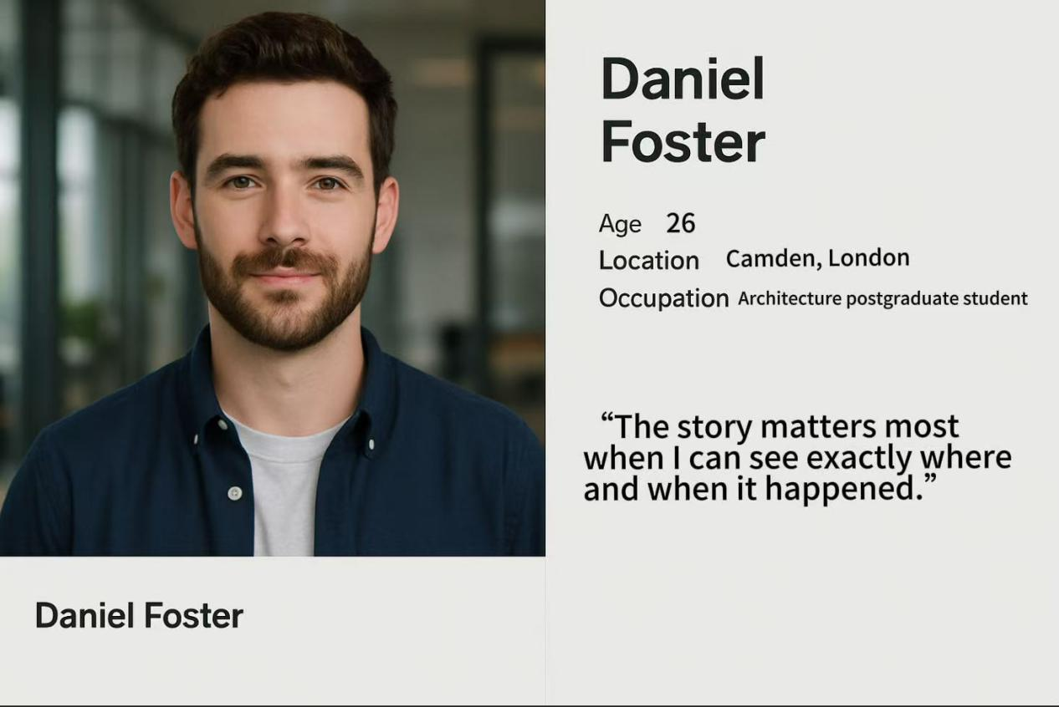

Name
Daniel Foster

Age
26

Location
Camden, London

Occupation
Architecture postgraduate student

Background / Context
Daniel recently moved to London for his postgraduate studies in architecture. He is deeply interested in post-war urban development and the cultural impact of disappearing social spaces such as pubs, clubs, and music venues.
As a digital native, he is confident using complex research tools, mapping software, and digital archives. However, he lacks direct personal experience of many lost spaces and relies on secondary sources.

Goals & Motivations
To access first-hand personal stories for academic research
To connect memories to specific geographic locations
To understand the emotional and social value of disappearing venues
To identify credible, well-documented historical material

Needs
Structured, searchable content
Story credibility indicators (date, location, supporting materials)
A map-based interface linking stories to places
Multiple information layers (audio, text, photos, archival references)

Pain Points
Difficulty assessing the reliability of user-generated stories
Fragmented information across different sources
Emotional distance from places he has never experienced
Academic frustration with uncontextualised anecdotes

Quote
“The story matters most when I can see exactly where and when it happened.”

PERSONA 3 Accessibility-Driven User
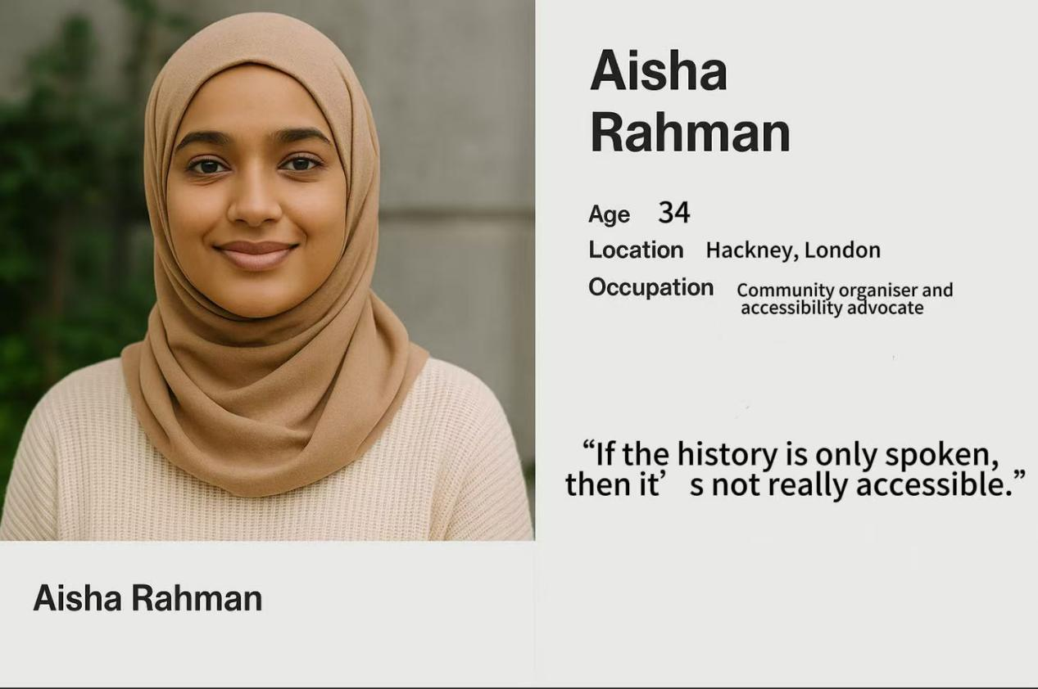

Name
Aisha Rahman

Age
34

Location
Hackney, London

Occupation
Community organiser and accessibility advocate

Background / Context
Aisha is a deaf user and a heavy user of digital technology. She is actively involved in the deaf and hard-of-hearing community and frequently advocates for inclusive design in public cultural institutions.
She strongly believes that cultural heritage should be accessible to everyone, regardless of physical ability. She often encounters audio-based content that lacks proper transcription or visual alternatives.

Goals & Motivations
To access oral histories on an equal basis
To engage with London’s cultural memory without barriers
To advocate for accessibility as a core design principle, not an add-on

Needs
Accurate and complete transcripts for all audio content
Optional real-time captions when audio is played
Clear visual hierarchy and readable layouts
Customisable accessibility settings

Pain Points
Audio-only storytelling excluding deaf users
Poor-quality or auto-generated transcripts
Accessibility features treated as optional or secondary
Feeling overlooked by cultural institutions

Quote
“If the history is only spoken, then it’s not really accessible.”

